7.54 Main Question (สำหรับแสดงข้อสอบ)

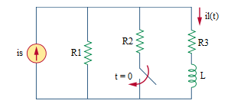

Given *is* = 2 A, *R*1 = 4 Ω, *R*2 = 12 Ω, *R*3 = 4 Ω, *L* = 3.5 H.

Find

Variables (สำหรับเขียนโค้ดเพื่อหาคำตอบ)

Random variables

is = {10:20:1};

r1 = {1:10:1};

r2 = {10:20:1};

r3 = {1:10:1};

l = {1:5:0.5};

time = {1:10};

Global variables

# is = 2; r1 = 4; r2 = 12; r3 = 4; l = 3.5; time = 1;

il0= (r1/(r1+r3))*is;

tau = l/(r3+((r1*r2)/(r1+r2)));

ilf = ((r1*r2)/(r1+r2)/(r3+((r1*r2)/(r1+r2))))*is;

ilt = ilf +(il0-ilf)*exp(-time);

Part (กรอกคำตอบ)

1. IL(0-) = il0 = 1 A

2. IL(0+) = il0 = 1 A

3. IL(∞) = ilf = 6/7 A

4. τ = tau = 0.5 s

At t>0

5. IL(t) = ilf+(il0- ilf)*exp(-t/tau) = 6/7+1/7*exp(-t/0.5) A

6. IL(timeτ) = ilt = 0.909 A

7.54b Main Question (สำหรับแสดงข้อสอบ)

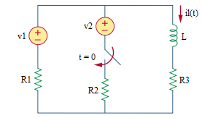

Given *vs*1 = 10 V, *vs*2 = 24 V, *R*1 = 2 Ω, *R*2 = 6 Ω, *R*3 = 3 Ω, *L* = 2 H.

Find

Variables (สำหรับเขียนโค้ดเพื่อหาคำตอบ)

Random variables

r1 = {1:10:1};

r2 = {1:10:1};

r3 = {1:10:1};

l = {1:10:1};

time {1:10};

Global variables

# v1 = 10; v2 = 24; r1 = 2; r2 = 6; r3 = 3; l = 2; time = 1;

tau = l/(r3+((r1*r2)/(r1+r2)));

il0 = v1/(r1+r3);

ilf = ((r2*r3*v1+r1*r3*v2)/(r1*r2+r2*r3+r1*r3))/r3;

ilt = ilf +(il0- ilf)*exp(-time);

Part (กรอกคำตอบ)

1. IL(0-) = il0 = 2 A

2. IL(0+) = il0 = 2 A

3. IL(∞) = ilf = 3 A

4. τ = tau = 4/9 s

At t>0

5. IL(t) = ilf+(il0- ilf)*exp(-t/tau) = 3-exp(-9t/4) A

6. IL(timeτ) = ilt = 2.63 A

7.60 Main Question (สำหรับแสดงข้อสอบ)

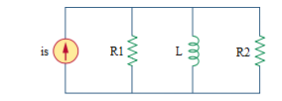

Given *is* = 4u(t) A, *R*1 = 5 Ω, *R*2 = 20 Ω, *L* = 8 H.

Find

Variables (สำหรับเขียนโค้ดเพื่อหาคำตอบ)

Random variables

r1 = {1:10:1};

r2 = {10:20:1};

l = {1:10:1};

time {1:10};

Global variables

# r1 = 5; r2 = 20; l = 8; time = 1;

tau = l/((r1*r2)/(r1+r2));

il0 = 0;

ilf = 4;

ilt = ilf +(il0- ilf)*exp(-time);

Part (กรอกคำตอบ)

1. IL(0-) = il0 = 0 A

2. IL(0+) = il0 = 0 A

3. IL(∞) = ilf = 4 A

4. τ = tau = 2 s

At t>0

5. IL(t) = ilf+(il0- ilf)*exp(-t/tau) = 4-4*exp(-t/2) A

6. IL(timeτ) = ilt = 2.52 A

7.61 Main Question (สำหรับแสดงข้อสอบ)

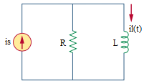

Given *is* = 5u(-t)+10u(t) A, *R* = 4 Ω, *L* = 0.5 H.

Find

Variables (สำหรับเขียนโค้ดเพื่อหาคำตอบ)

Random variables

r = {1:10:1};

l = {1:5:0.5};

time {1:10};

Global variables

# r = 4; l = 0.5H; time = 1;

tau = l/r;

il0 = 5;

ilf = 10;

ilt = ilf +( il0- ilf)*exp(-time);

Part (กรอกคำตอบ)

1. IL(0-) = il0 = 5 A

2. IL(0+) = il0 = 5 A

3. IL(∞) = ilf = 10 A

4. τ = tau = 1/8 s

At t>0

5. IL(t) = ilf+(il0- ilf)*exp(-t/tau) = 10-5*exp(-8t) A

6. IL(timeτ) = ilt = 8.16 A

7.63 Main Question (สำหรับแสดงข้อสอบ)

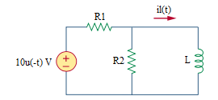

Given *vs* = 10u(-t) V, *R*1 = 5 Ω, *R*2 = 20 Ω, *L* = 2 H.

Find

Variables (สำหรับเขียนโค้ดเพื่อหาคำตอบ)

Random variables

r1 = {1:10:1};

r2 = {10:20:1};

l = {1:10:1};

time {1:10};

Global variables

# r1 = 5; r2 = 20; l = 2; time = 1;

il0 = 10/r1;

ilf = 0;

tau = l/((r1*r2)/(r1+r2));

ilt = ilf +(il0- ilf)*exp(-time);

Part (กรอกคำตอบ)

1. IL(0-) = il0 = 2 A

2. IL(0+) = il0 = 2 A

3. IL(∞) = ilf = 0 A

4. τ = tau = 1/8 s

At t>0

5. IL(t) = ilf+(il0- ilf)*exp(-t/tau) = 2*exp(-8t) A

6. IL(timeτ) = ilt = 0.735 A